**OUTPUT**

**1.a)** Get all the countries from Asia continent /region using Filter function

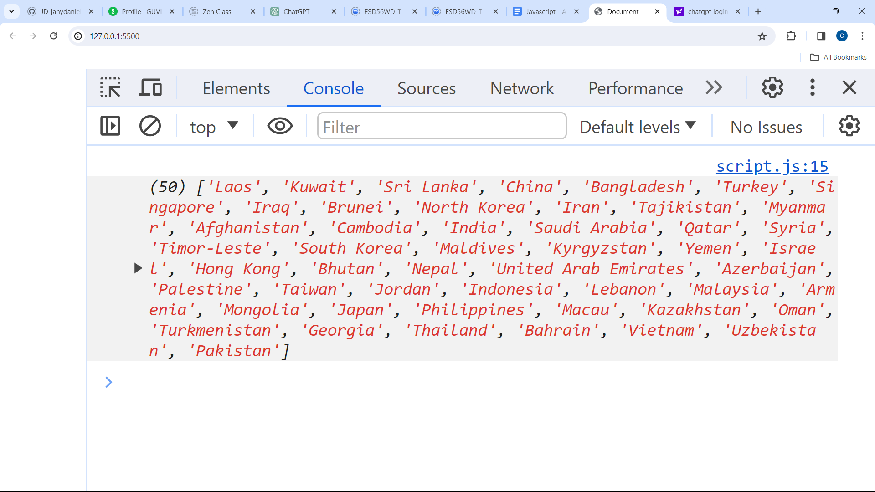

**1.b)** Get all the countries with a population of less than 2 lakhs using Filter function

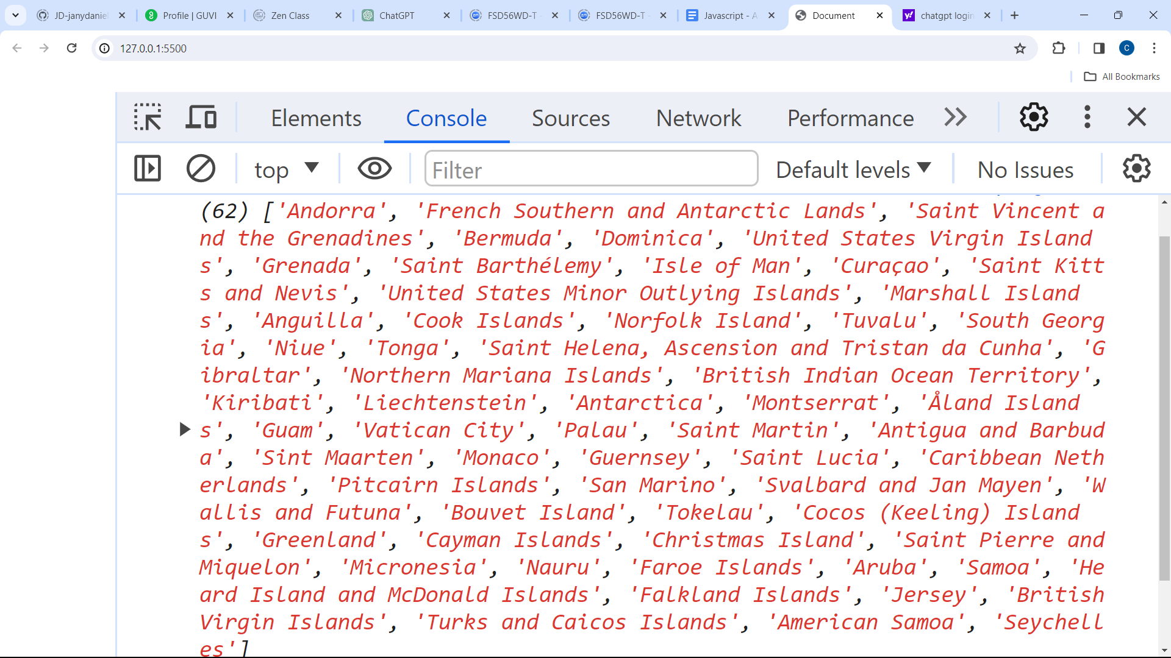

**1.c)** Print the following details name, capital, flag, using forEach function

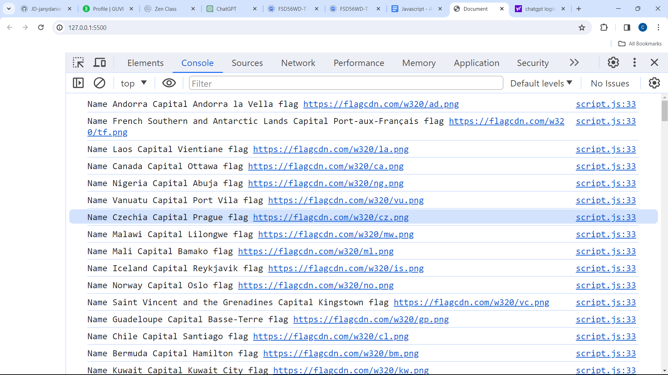

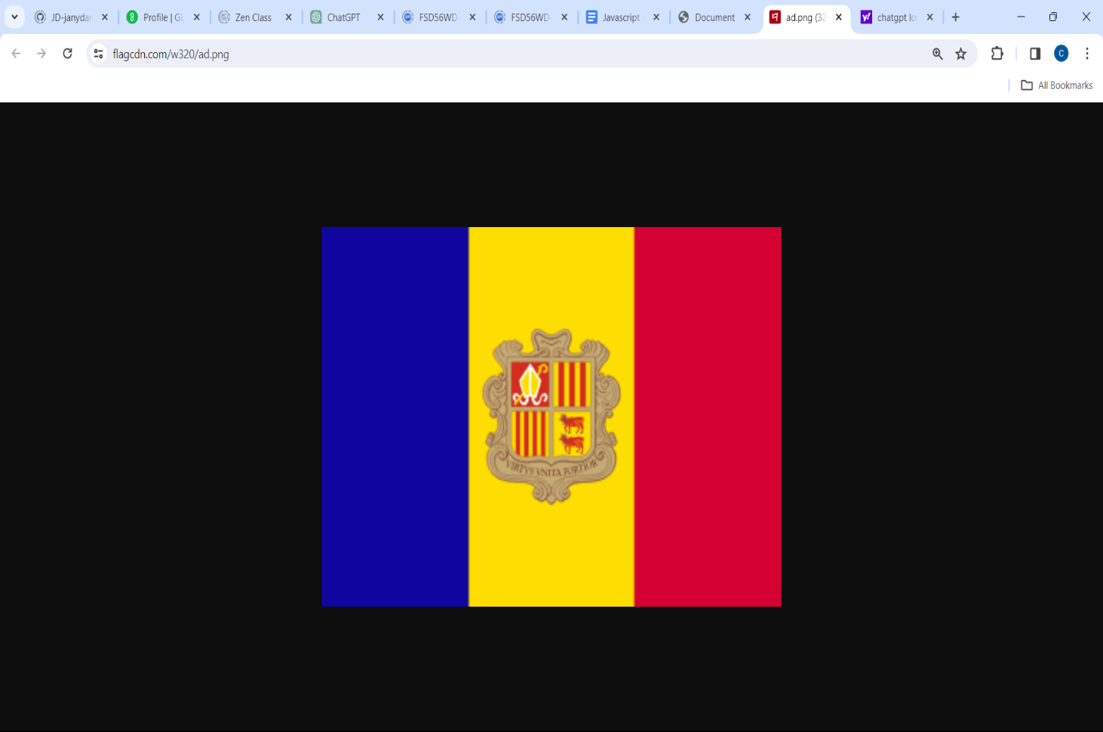



**1.d)** Print the total population of countries using reduce function

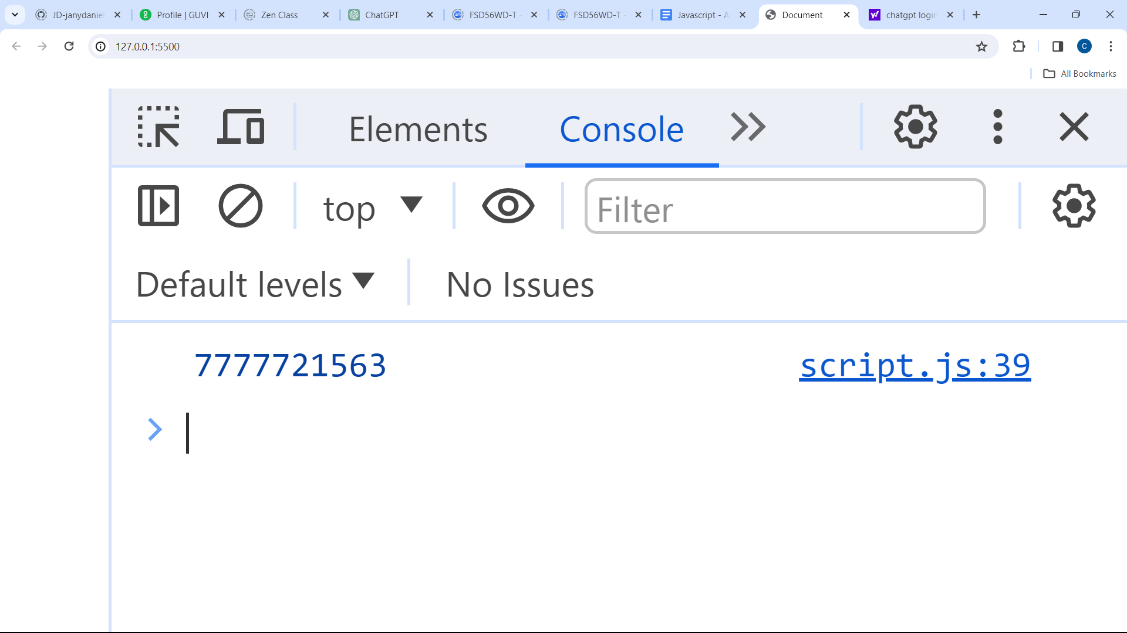

**1.e)** Print the country that uses US dollars as currency.

